How to use Opportunity/Procurement in BETA.SAM (Eric's take)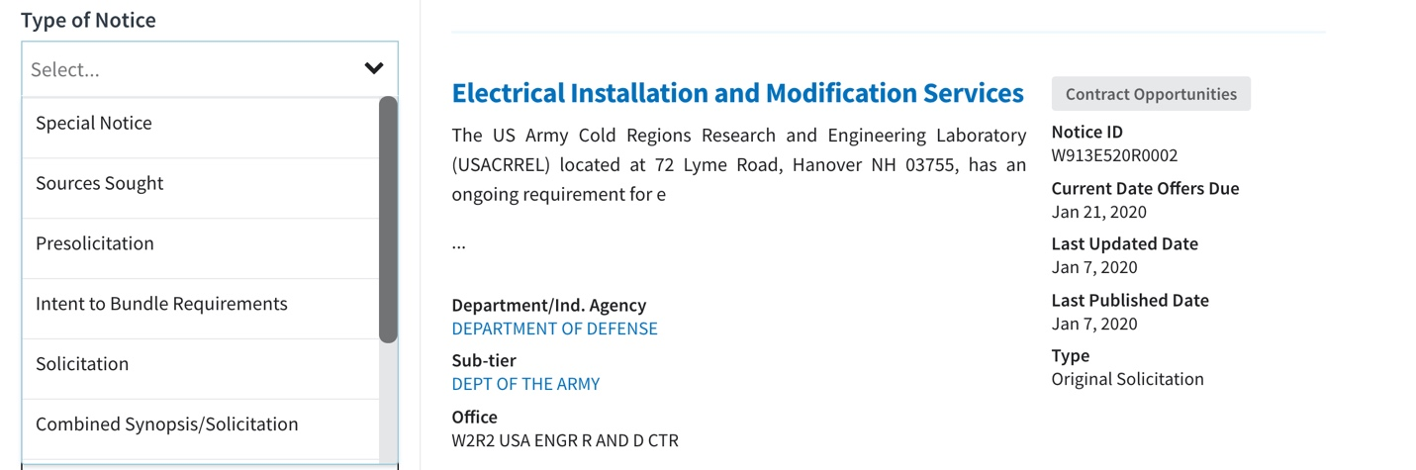
You might have read the email about understanding BETA.SAM opportunity/procurement activity.

Today I want to offer up my perspective on how I utilize these tools to grow my business.

Award – I utilize this list to identify subcontract opportunities. If someone recently was awarded a project that includes SOW in your respective field than you have the right and obligation to pursue that person/firm directly for work.

I would reach out to them immediately to see if they have all their suppliers/contractors in place. Send them an email AND call them to find out if they have any gaps in scope.

Even if they have a supplier, I would ask to see if they want to consider my pricing as well. Who doesn't want better pricing and more options?

For an example on how this works watch this video.
Combined Synopsis / Solicitation – I use this to do a few things:
- Find new clients that are spending funds in my NAICS code - I ask the CO/COTR (Contract Officer/Contract Officer Technical Representative) for the POC (point of contact) information of their OSDBU (office of small disadvantage business utilization) office. I than let the OSDBU know that I am interested in working with their agency to pursue this type of work.
- Identify opportunities to build relationships with my existing TML (target market list) customers. Before you are awarded sole source or SAP (simplified acquisition procedures) opportunities agencies want to first see how you bid and perform. This is a way to demonstrate you have what it takes.
- Get access to government installations for meetings/visits. I look for the site visits at facilities where I need access to meet with the Contract office team.
Sources Sought (SS) – This is the perfect way to make relationships with contract offices.

If you are interested in doing business with an agency, this is the #1 way to get noticed.

Respond to the request with a "letter of interest" (LOI) answering all the client questions in the sources sought notice. Many times they want to see that you have performed similar work of size, scope and nature in the past.

Don't forget to include a copy of your capabilities statement with your LOI when responding to the notice.

Need help with your firms capability statement, head over to the website, https://templatecapstatements.com/en/ for free and low cost templates.

Need a sample copy of a my letter of interest. Click this link to download your FREE sample.
Pre-solicitation – This is the chance to learn about a project and prepare ahead of time. If it is something that I like, I immediately start building my TEAM who will help me price the job.

Often times if we wait until the solicitation hits the streets it will be too late.
Special Notice – If this is a sole source notice. Again you have the opportunity to pursue the Awarded firm for potential work.

Many times it is useful information to learn who is the preferred vendor for this agency and that NAICS code.
Synopsis / Solicitation Amendment – Nothing to do here.

